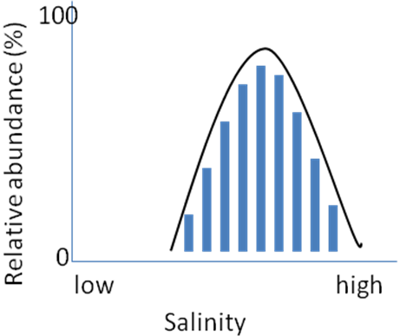1. The following graph shows the distribution of sea nettles in Chesapeake Bay in relation to salinity. At which salinity level (indicated by a letter) would a sea nettle survive but be most stressed?

- A
- B
- C
- Sea nettles would not be stressed at any of the indicated salinity levels
C
B
A
- Sea nettles would be equally stressed at all 3 salinity levels

2. We use DNA polymerase from Thermophilus aquaticus (fondly referred to as Taq) for PCR. Why can’t we use DNA polymerase from Escherichia coli (fondly referred to as E. coli) for PCR?

3. Here are the precipitation tolerances for Oil palm trees (100-350 cm year⁻¹) and Saguaro cactuses (8-40 cm year⁻¹). Draw the curves on the same graph. Which appears to be more of a specialist?

5. Examine the following graph and explain why species ranges shifted.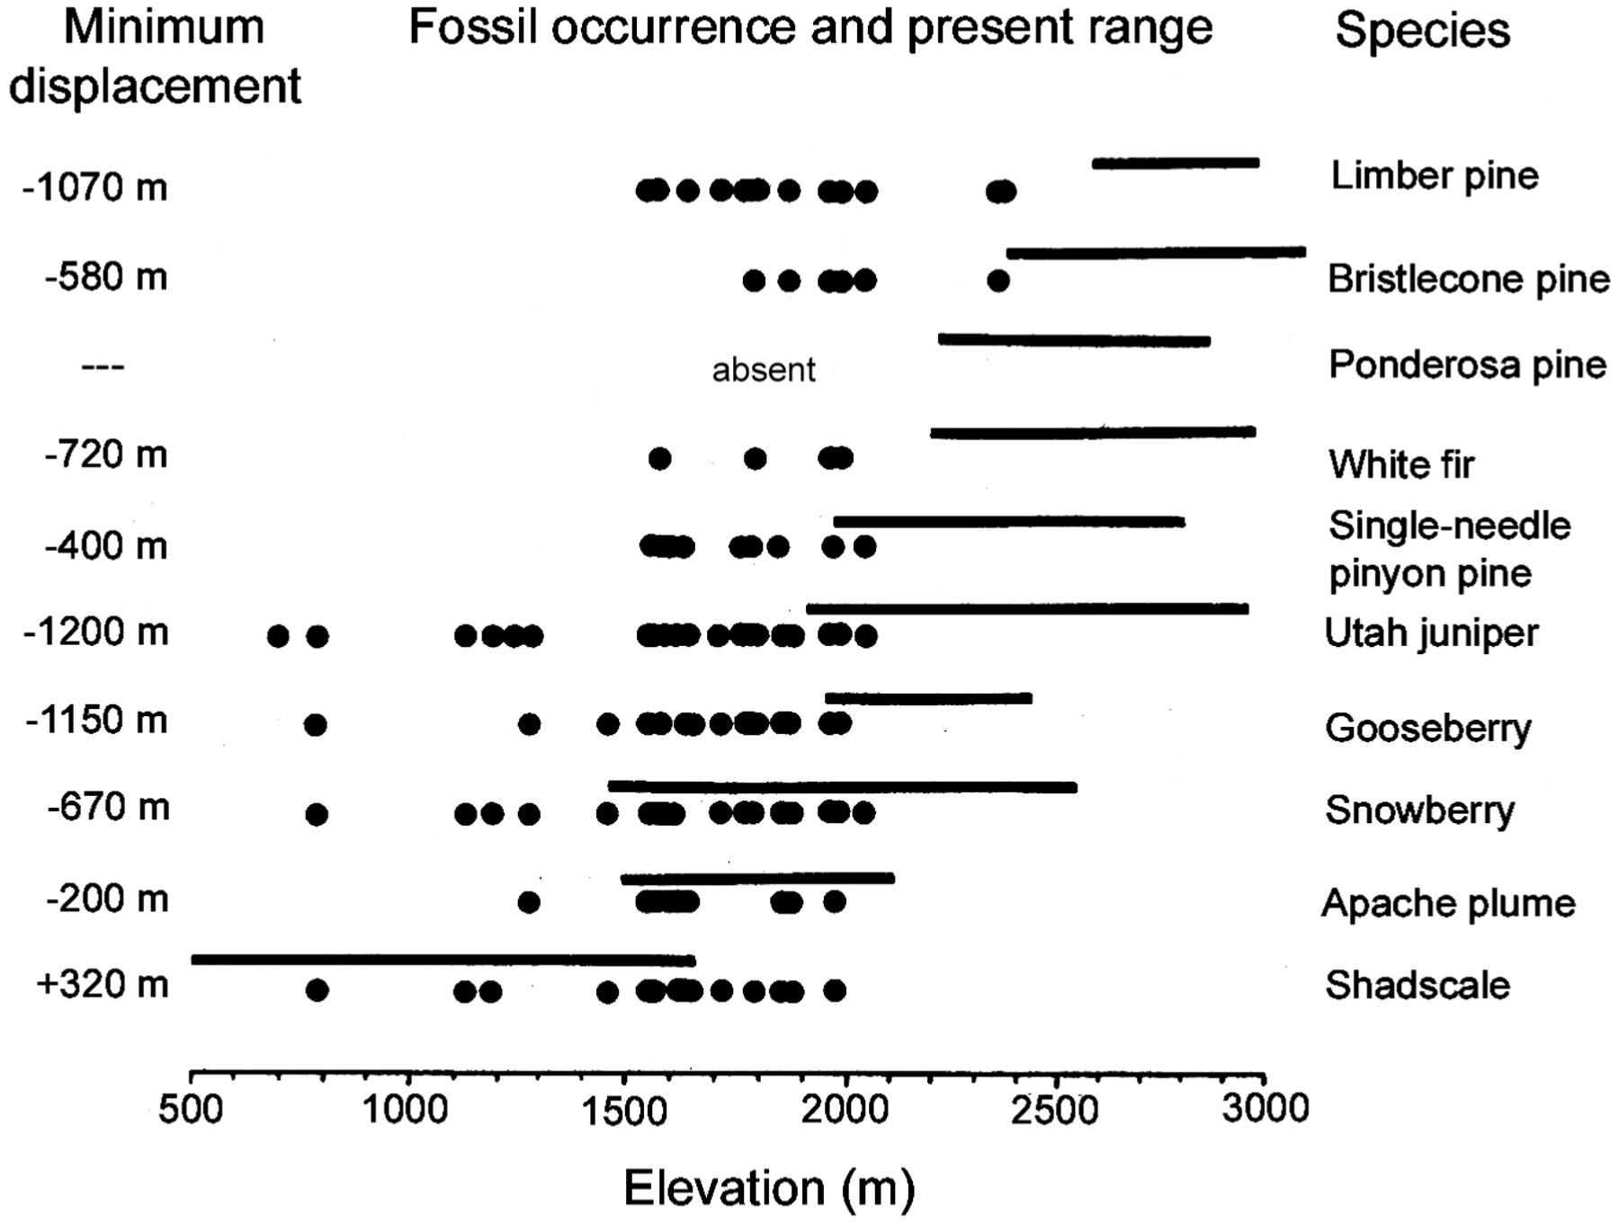 Give as many reasons as you can for why distributions shifted, and state if each reason involves niche shift or not.

6. If over the course of the next 2000 years the white-tailed deer evolves thicker fur, which of the following is most likely to happen to its ecological niche:

- It will move northward on the globe.
- It will move southward on the globe
- It will not change
- Its temperature distribution will shift towards warmer temperatures
- Its temperature distribution will shift towards cooler temperatures

